The Gao Family History

- The Gao Family Book
- The Origins of the Gao Family
- The Twentieth Century
- Nowadays
- China
- Why?
- Photographs

A brief note:
Last summer, my grandmother’s university classmate’s ex-husband’s new wife mentioned that she had once sold a violin to a Taiwanese man, Mr Gao, and offered to put me in contact with him. I was grateful for the offer but expected little to come of such an extraordinarily tenuous link. Yet, throughout the past six months in Taipei, the family have been incredibly generous and kind to me, inviting me to their family gatherings and on adventures all around Taiwan. I am immensely grateful to them.

In October, Mr Gao asked me to help his grandson, Hector, with a project on their family history. He wanted Hector to prepare a presentation for the family’s annual Chinese New Year gathering, but to do so in both Chinese and English. Having spent a while working on that project, and even longer listening to Mr Gao’s extensive family stories, it felt odd for me to request to do a single interview for this essay. Instead, this is a compilation of the various tales and conversations I have had with the family over the past few months, written with their permission. The photos included are from Mr Gao’s powerpoint.

1.The Gao Family Book

In the Gao family home on the outskirts of Taipei lies a book. The book is thicker than most, a heavy hardback bound in auspicious red, and accompanied by a slimmer, flimsier white version. On the outside it reads in embossed gold characters ‘高氏族譜’.

This is the Gao Family Book, and it asserts to contain the name of almost every male member of the Gao family who has descended from Gao Hong, prefect of the Bohai county during the latter part of the Han dynasty. For Mr Gao, living in 21st century Taipei, it allows him to claim to be able to track 2000 years of his family history all the way back to Han dynasty China.

Open the book and you will find that it is hundreds of pages long, each page crammed full of tiny, printed names, every single one starting with the same surname of高. It is easy to get lost in the labyrinth of people and dates, and so Mr Gao has highlighted his own family line in a bright yellow, with scribbled notes marking when to jump forward thirty pages or so, skipping over thousands of distant cousins. Every name is marked alongside a generational number, with Gao Hong starting as the first generation. Mr Gao’s own family line in the book ends at the 38th generation; he himself can claim to be the 39th .

According to Mr Gao, the record was started by the 8th generation, and has been kept up ever since. There was a moment during the cultural revolution when most copies of the book were destroyed, but he tells me how a few members of his family in Anxi in the Fujian province of China worked painstakingly for many years to reconstruct the new version. When I ask why so many people for so many hundreds of years had taken such effort to maintain this record, he tells me he thinks it is because of the Chinese tradition of believing your ancestors’ spirits live on and hold influence over your lives. Maintaining this book is a sign of respect – failing to maintain it could be deeply offensive.

If accurate, the book is a remarkable record of history. Even if inaccurate, it is a remarkable product of an extended Chinese family’s dedication to their own sense of history.

Perhaps most remarkable is that the generational markers do not exist simply to tell the reader how many great-grandfathers lie between himself and the famous Gao Hong, they also inform you what you should name your children. Mr Gao tells me that, not only did someone thousands of years ago think it worth starting a record of every male relative, but they also thought it worth creating a list of sixty characters, with each character designated to be the middle character of the names of every relative born to that generation.

At some point, someone decided that this random list was far too confusing and changed the characters so that they followed some sort of logical pattern. The radical of each character now rotates through five elements – 土, 金, 水, 木 and火 – in that order and can be seen in the modern Gao family.

The middle character of Mr Gao’s name is 樹, clearly marked with a tree radical. According to the list, his grandson, Hector, ought to be 堂, with the earth radical, but Mr Gao tells me that they chose not to use it because 高堂 would sound more like a dessert than a name. The 10-year-old Hector laughs at this thought of his name meaning a sugary treat. I then ask him if he will use the assigned character of 錦 for his own children and he says of course.

Mr Gao tells me how this system also easily allows for the reconnection with distant relatives. Since the reopening of travel to China in the 1980s, Mr Gao has been back to Anxi several times, the last place his family lived before they emigrated to Taiwan in the 1700s. He recounts to me how he once got in a taxi on the way to the airport and noticed that the driver’s name started with 高炳, which, according to the name list, indicated that he was part of the 40th generation, one below Mr Gao. ‘You should call me Uncle!’ Mr Gao told the man, who then drove him not to the airport but to an elderly uncle of his who was obsessed with the family history and naming system. Mr Gao tells me that they had chatted for hours, and the same stories and names had clearly permeated for centuries, even as the family had split up and some moved across the sea to Taiwan.

2.The Origins of the Gao Family

It are these stories that form the basis of the presentation that Mr Gao asked Hector to give about their family history at Chinese New Year.

According to Mr Gao, records of his family history start with Gao Hong, a man who was appointed to govern over the Bohai Sea region during the latter Han Dynasty. Located in the North of China, the Bohai sea is enclosed by the modern-day Hebei, Liaoning, and Shandong provinces, as well as the municipality of Tianjin. At some point over the following several hundred years, part of the family ended up in the Gushi county in Guangzhou, Henan. In 881, the Huangchao Rebellion broke out and so, in order to escape the trouble, Gao Gang moved his family south from Henan to Fenggang in Fuzhou, Fujian. Over the next several hundred years, his line of the family would move around more within the Fujian province, with Gao Shan of the 17th generation choosing to settle in Daping, Anxi. Mr Gao tells me that this was to avoid the chaos at the end of the Yuan dynasty.
Anxi is therefore where Mr Gao considers to be his ancestral home on mainland China. He tells me how, in the 1980s, travel between Taiwan and China was first only opened for soldiers who wished to visit their family home. Desperate to visit Anxi, Mr Gao pretended to qualify and managed to go back there, where he found his Gao family ancestral hall.

Mr Gao’s ancestors’ move to Taiwan came in the middle of 18th century when the Qing emperor Qianlong was ruling China. The 30th and 31st generations of his family, faced with terrible conditions and a chronic lack of food in Anxi, made the brave decision to sail to Taiwan, where they had heard of many immigrants successfully building new homes. Mr Gao tells me that at the time the sea crossing to Taiwan was extremely dangerous, with as few as one in three surviving the journey. Just as rebellions and disorder had prompted some of their ancestors’ previous moves, once again, the family was migrating out of desperation.

Having safely made it, Mr Gao’s family eventually settled in Muzha, an area which lies just to the south of Taipei. There, they grew tea, with the tea fields of Muzha closely resembling those of their home in Anxi, allowing for them to easily transfer their cultivation skills. Mr Gao shows me pictures of Hector at the Gao Ancestral Hall in Muzha, which, to my amazement, is clearly marked with ‘渤海’, indicating which Gao family they had descended from 2000 years ago.

3.The Twentieth Century
…….

6.Why?

When working on the presentation, there was one question which Hector asked me a million times over: why do I have to do this? Sometimes, the question would come in its more interesting iteration: why does my grandfather want me to do this?

This is a question I asked Mr Gao myself, and at first, he responded that he would think about it. Then, he came back with an answer.

The reason he cared so much about teaching his grandchildren their family history is because he wanted his grandchildren to know that they could not rely on anything in life except their own hard work. Throughout history, his family’s fortunes had been turned and shaped by matters out of control of the individuals affected; from the Huangchao Rebellion of 881 to the hunger of the 1700s to the arrest of his own grandfather. His family history taught his grandchildren that they could not take anything for granted.

Mr Gao thus selected two poems to end the presentation, explaining why the Gao family story mattered so much. The first is a warning about complacency, the second is hope for the future.

Poem 1:
財富、權勢
不可靠
不可依賴

Poem 2: 期許高家子弟
腳 踏 實 地
勤 奮 工 作
敬 天 愛 人
厚 道 傳 家

On a personal level, he also said that he was simply a very curious man.

7.Photographs
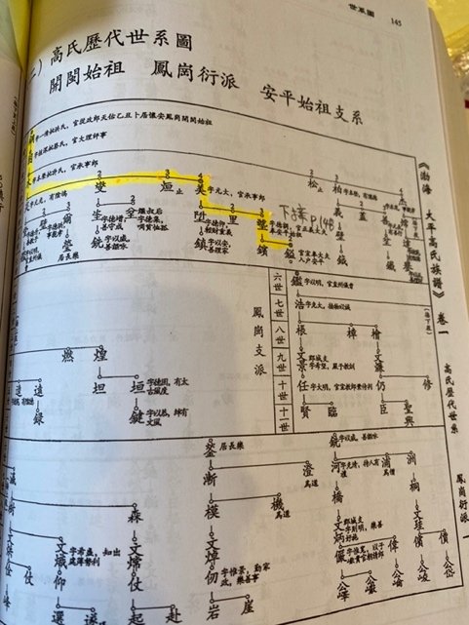
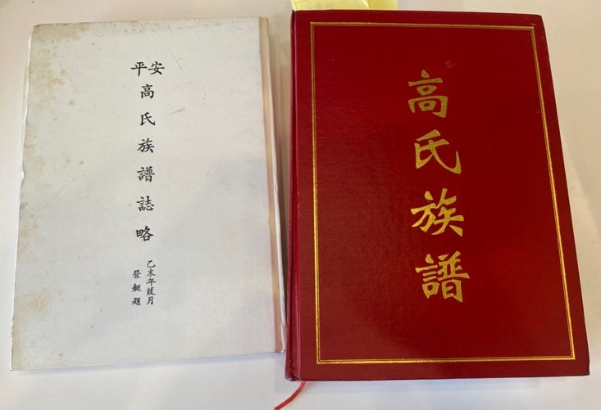
Figure 1: The Gao Family Books. The white book only accounts the family in Taiwan.

Figure 2: The first few generations in the Gao Family Book
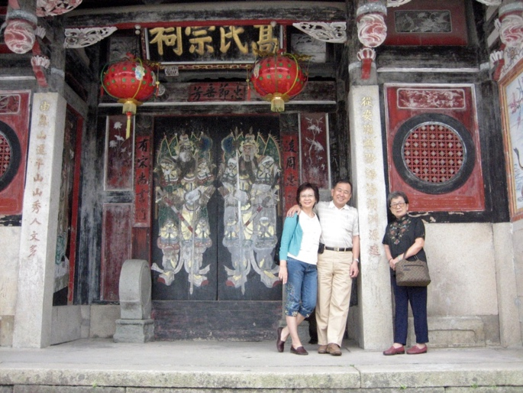
Figure 3: Mr Gao with his wife and mother at the Gao family ancestral hall in Anxi, Fujian.
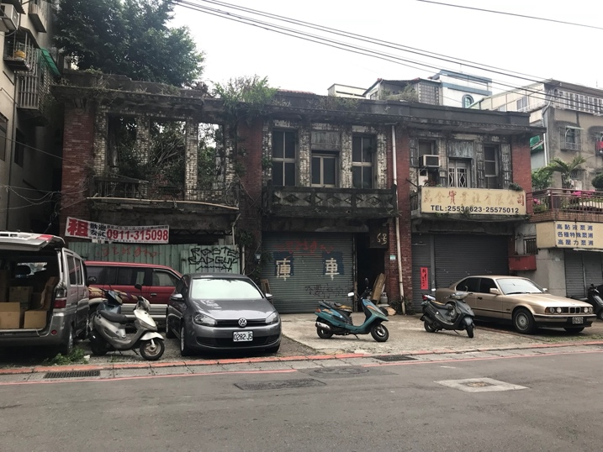

Figure 4: Mr Gao's mother's childhood home still lying derelict today
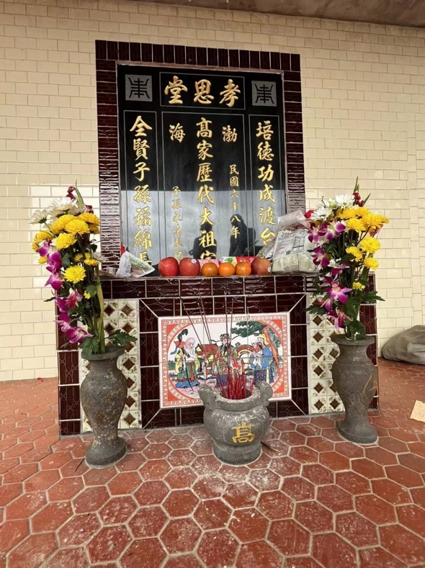
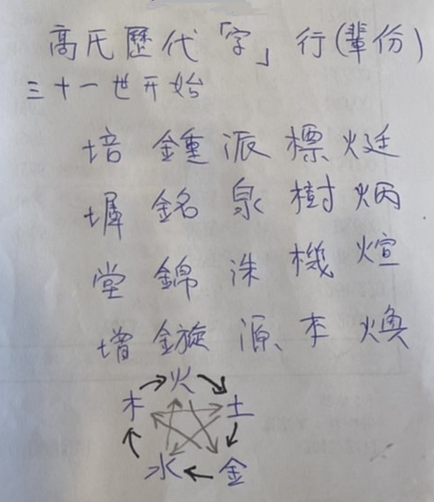

Figure 5: The Gao Ancestral Hall in Muzha, Taiwan. You can see 渤海 clearly written on the wall.
Figure 6: Mr Gao's handwritten notes attempting to explain his family naming system

